

Chaos Ex Machina:

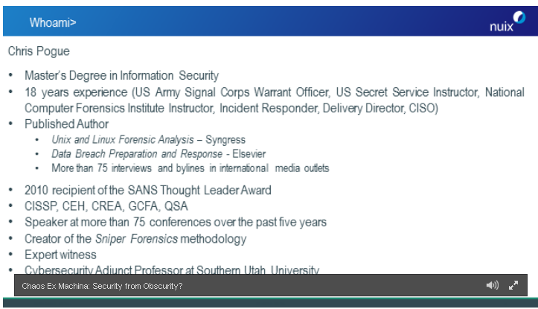

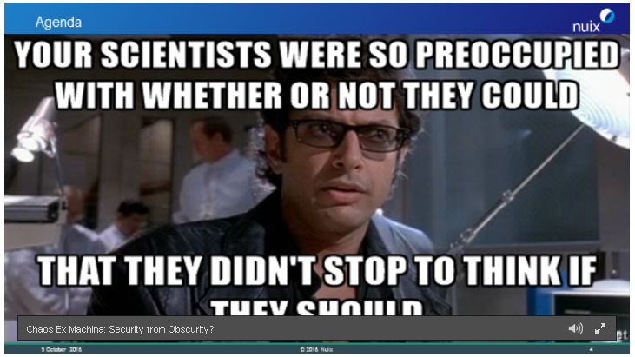

Our Digital footprint: we are seeing greater and greater technology over time. “An amazing amount of data that is there

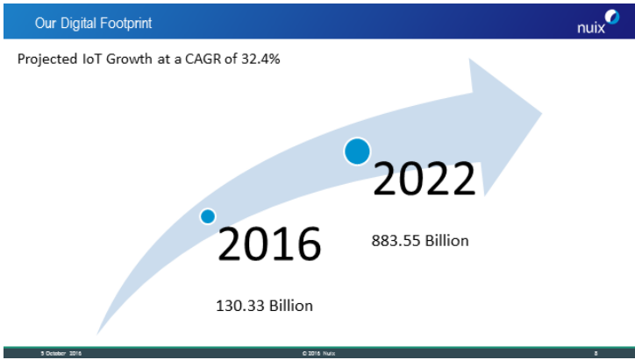

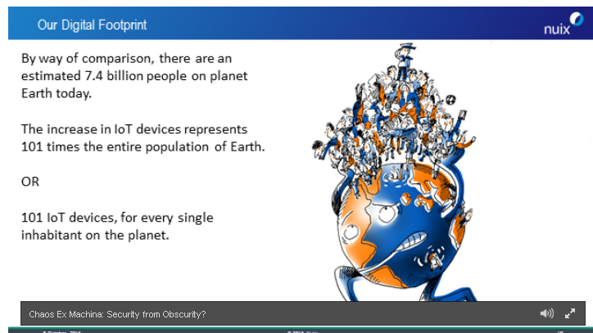

IOT device

Compares it to pong. Single functional devices. We have this techno trash.



Security seems to be an after thought, security doesnt sale. Patch wednesday’s, it is good enough to sale. We will fix it later

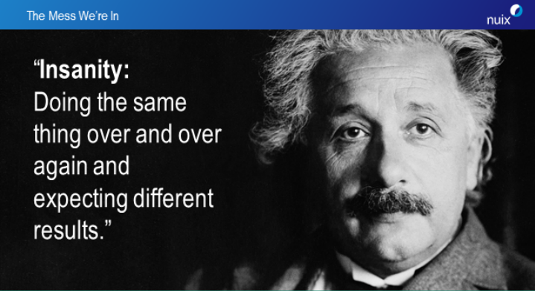



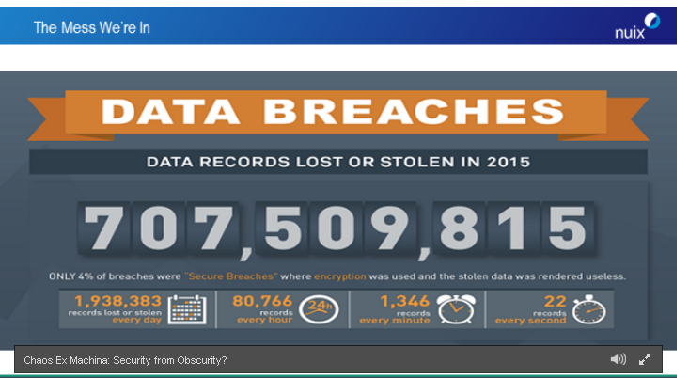

We have been desensized to it

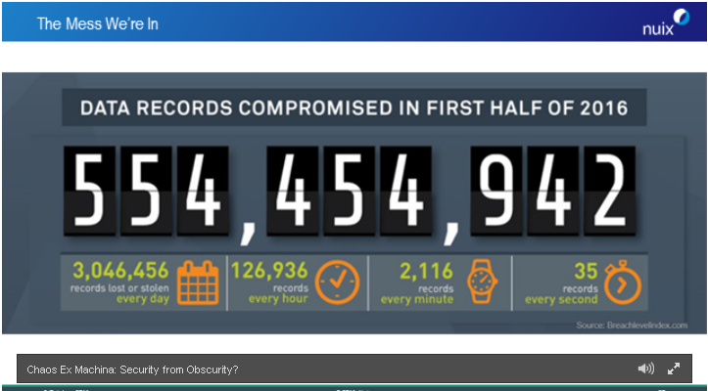

We arent any better at securing our data, we have massive amount of data but we dont know how to secure it. What is all this data doing to us? What is our plan for managing it?



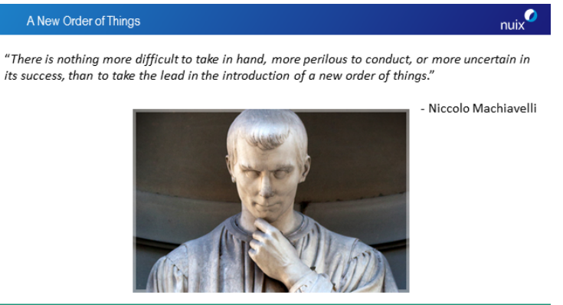

Chaos vs order: compares wiring in a server room

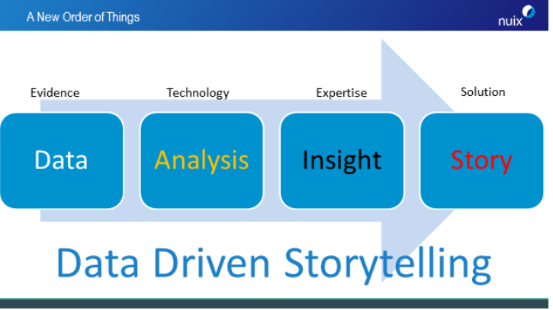

Target data breach was a peaking point. We are going to have to see the loss of human life to see the next peak. Everything we are doing as a security professional involves me telling a story. Our ablility to move forward will be dependent on our story telling. POLE:People, Objects, Location, and Events. 200 to 300 days on adverage to find a breach.

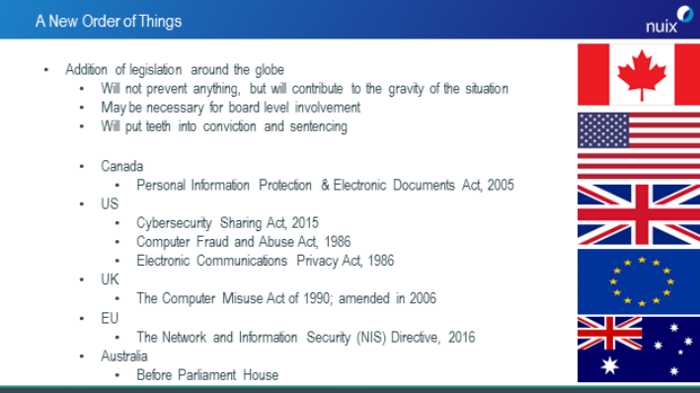



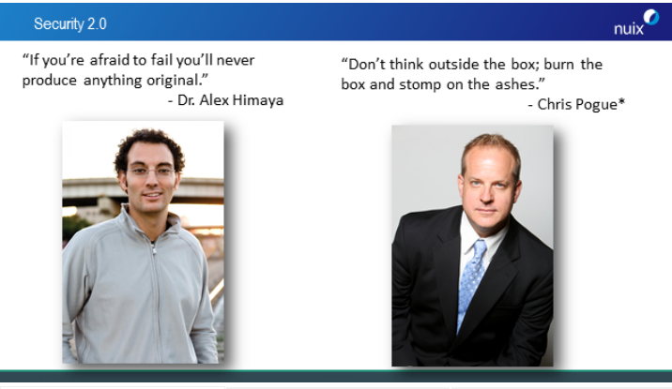

We need to look at how to look at security diffently. We need to come up will a different strategy on how to better secure our data. perspective(Island example). Once we can expatiate data, then we can give it meaning. All data meaning. How to solve this funding for security, tangitive impact, laws,

Breach breakdown

Maxstrip

<https://www.brighttalk.com/webcast/11399/222471?utm_campaign=communication_reminder_starting_now_registrants&utm_medium=email&utm_source=brighttalk-transact&utm_content=button>